- Frontend Form with MongoDB Atlas
- Create a form on the frontend that, when submitted, inserts data into MongoDB Atlas.
- On success: the user should be redirected to another page displaying the message “Data submitted successfully”.
- On error: display the error on the same page without redirection.

- Connect the frontend form to MongoDB Atlas
This task needs a MongoDB Atlas database. Installing Python packages alone does not create the database or configure the connection.
Step 1: Create or access your Atlas cluster
Open MongoDB Atlas and sign in. Create a cluster if you don't already have one.
Step 2: Configure database access
- Create a database user with a username and password.
- Under Network Access, allow your current public IP address.
- Keep the database credentials private.
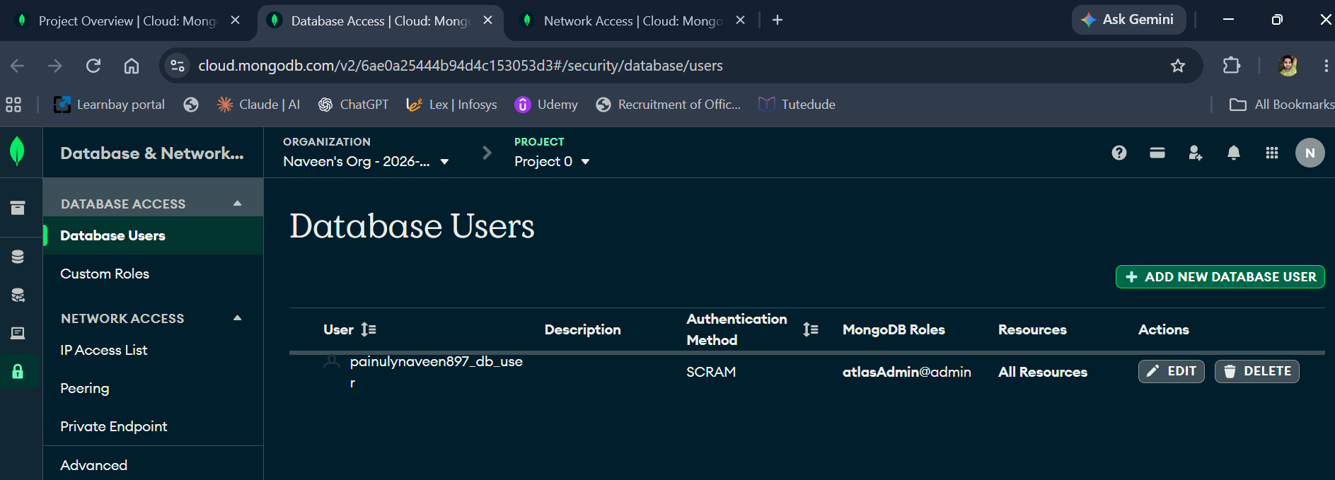
Step 3: Get your Python connection string
- In Atlas, select your cluster, click Connect, choose Drivers, and copy the Python connection string.
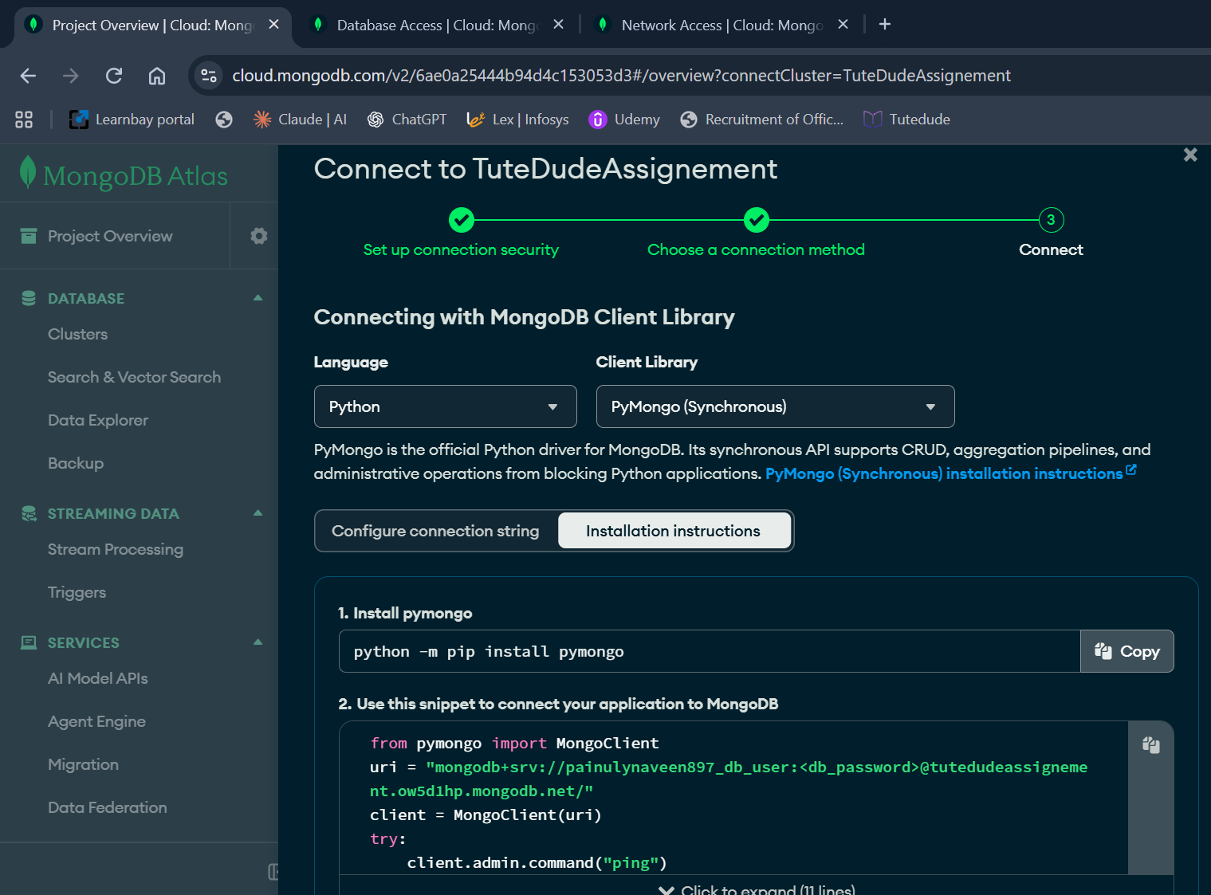
- Configure the .env file
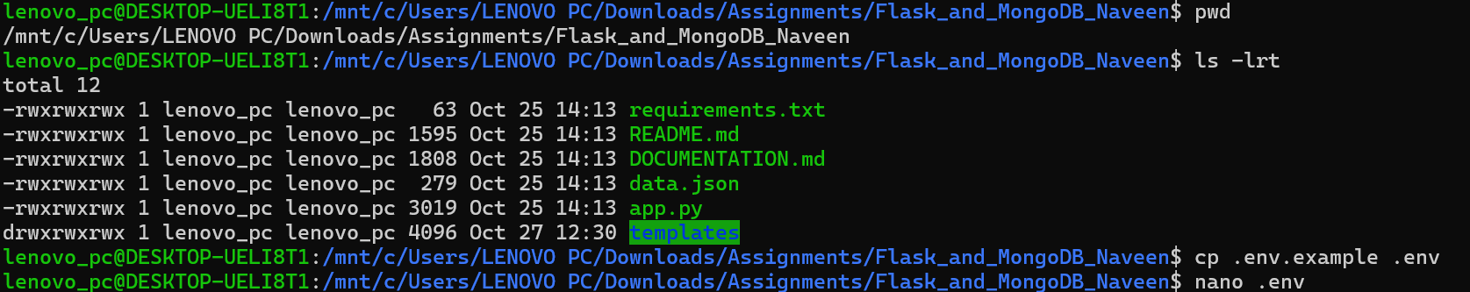
- Put the connection and DB details in .env file as mention in my actual Atlas connection string. Username and password is hide for privacy purpose.
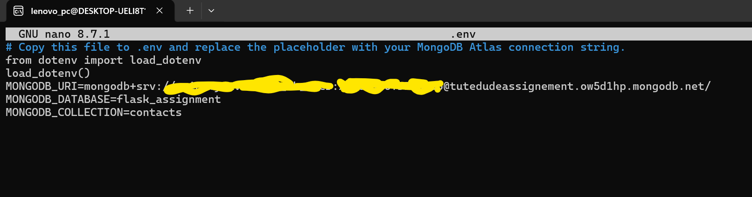

- After saving the file and re-run the app.py file, its time to test the connectivity.
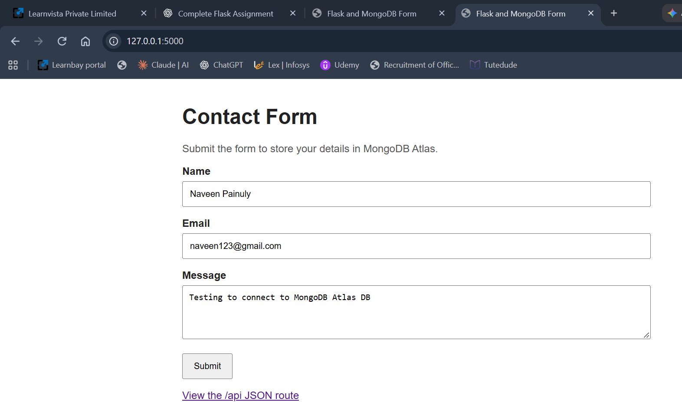
- Now here comes, testing part for Flask and MongoDB Atlas integration. The application must redirect you to /success and displayed the required message, Data submitted successfully.
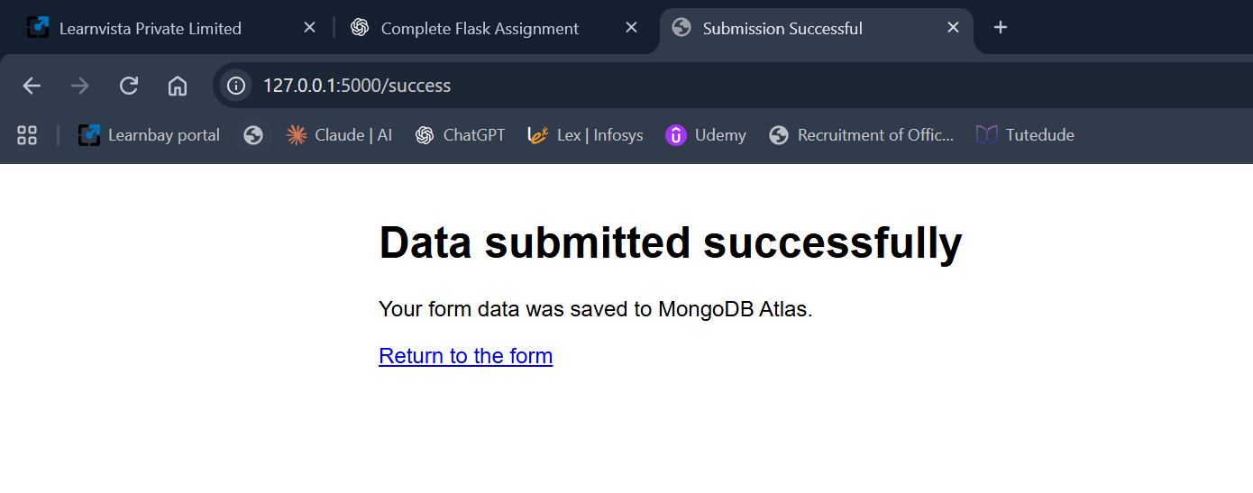
***************************End of Assignment******************************

